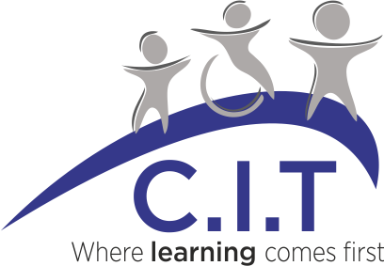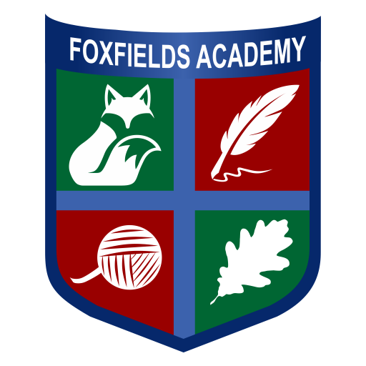

**Overview**

Academic Year – 2024-2025

Date this summary was published: September 2024

Date this summary will be reviewed: September 2025

Name of school music lead: Beth Simpson

Name of Local Music Hub: Leicestershire Music Hub

**Overall objective/vision:**

At Foxfields our curriculum intent is as follows –

*‘A tailored curriculum designed to prepare our pupils to be confident and successful individuals who make outstanding progress and are prepared for life after school.’*

**Part A: Curriculum Music**

Our aim is to provide a rich, diverse, and progressive music curriculum for all children. There are opportunities to learn musical instruments, participate in performances in both the school and the local community and take part in music therapy sessions. This will maximise cultural capital for all pupils, support their overall wellbeing and confidence, whilst creating a supportive community of music making.

At Foxfields Academy, we use the Kapow Primary Music Scheme across our Lower and Middle School.

Our scheme of work fulfils the statutory requirements of the National Curriculum (2014). The National Curriculum for Music aims to ensure that all pupils:

• Perform, listen to, review and evaluate music across a range of historical periods, genres, styles and traditions, including the works of the great composers and musicians

• Learn to sing and to use their voices, to create and compose music on their own and with others, have the opportunity to learn a musical instrument, use technology appropriately and have the opportunity to progress to the next level of musical excellence

• Understand and explore how music is created, produced and communicated, including through the inter-related dimensions: pitch, duration, dynamics, tempo, timbre, texture, structure and appropriate musical notations.

In accordance with the National Curriculum, we ensure that coverage of knowledge and skills is developed sequentially throughout the school. We have adopted the Kapow Scheme, to ensure that children receive quality music lessons throughout the year – we cover one unit per half-term. Music is taught as a discrete lesson lasting, 40mins.

We explore music through the inter-related dimensions of music: performing, listening, composing, the history of music. We focus on developing the skills, knowledge and understanding that children need in order to become confident performers, composers, and listeners. Children will develop the musical skills of singing, playing tuned and un-tuned instruments, improvising and composing music, and listening and responding to music.

Kapow Primary’s Music scheme which has been designed as a spiral curriculum with the following key principles in mind:

• Cyclical: Pupils return to the same skills and knowledge again and again during their time in primary school.

• Increasing depth: Each time a skill or area of knowledge is revisited it, is covered with greater depth.

• Prior knowledge: Upon returning to a skill, prior knowledge is utilised so pupils can build upon previous foundations, rather than starting again.

Our curriculum introduces children to music from all around the world and across generations, thereby helping them to develop an understanding of the history and cultural context of the music that they listen to and teaching them to respect and appreciate the music of all traditions and communities.

Pupils are taught musical notation and how to compose music. Composing or performing using body percussion and vocal sounds is also part of the curriculum, which develops the understanding of musical elements without the added complexity of an instrument. Children develop descriptive skills in music lessons when learning about how music can represent feelings and emotions. We teach them the disciplined skills of recognising pulse and pitch.

Music based therapies including music therapy and noise academy, are offered weekly on an individualised basis and pupils have the opportunity to work towards certificates and awards based on the different levels. Music produced during the noise academy sessions are shared with the general public for others to enjoy the pupil’s compositions.

Through music, our curriculum helps children develop transferable skills such as team-working, leadership, creative thinking, problem-solving, decision-making, and presentation and performance skills. These skills are vital to children’s development as learners and have a wider application in their general lives outside and beyond school.

**Part B: Co-Curricular Music**

We offer individual and group music therapy sessions weekly and specialist teachers come in to deliver these sessions. Pupils access music through our wider curriculum and teachers make explicit links where possible e.g. rainforest sounds in Geography and Gospel music in RE.

We have a Lower School Choir which have performed in both the school assemblies and the wider local community including churches and local care homes.

Pupils have the opportunity to perform their musical instrument in front of an audience such as in assembly.

**Part C: Musical Experiences**

In addition to planned curriculum time for music, children also have additional musical experiences, sometimes the whole school together, sometimes individually, which occur during the school year and contribute to the overall planning and time allocation for music, e.g. attending a pantomime.

Music is incorporated into a variety of activities and events within school, such as weekly assemblies, classroom routines and special celebrations.

Music based therapies including music therapy and noise academy, are offered weekly on an individualised basis and pupils have the opportunity to work towards certificates and awards based on the different levels. Music produced during the noise academy sessions are shared with the public for others to enjoy the pupil’s compositions.

**In The Future**

We are dedicated to continuously enhancing our music education provision to ensure that it meets the highest standards and provides enriching experiences for all our students.

* Develop equipment in school to match growing number of pupils on roll.
* CPD planning – plan CPD for classroom teachers to increase confidence in classroom delivery.
* Performance opportunities - broaden the range of performance opportunities for children in school and beyond for parents to attend: Young Voices, performing at the Curve (local theatre), class and choir performances.
* Additional funding from hub/charities/fundraising – proactively try to find additional funding for music (e.g. PTA; local charities; fundraising in school from performances etc.)